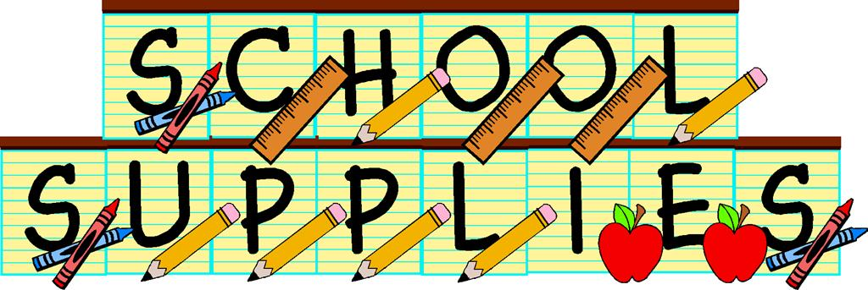

**1- Zippered Pencil Pouch**

**2- Packs of No. 2 Pencils (24 count)**

**1- Enclosed Pencil Sharpener**

**1- Pack of Colored Pens**

**2- Packs of Erasable Pens (blue& black)**

**2- Highlighters**

**2- Pink erasers**

**1- Boxes of Crayola Crayons 24ct.**

**1- Packs of Crayola Markers**

**1- Pair of Blunt tip Scissors**

**2- Large Glue Sticks**

**1- Pack of Small Index cards (lined)**

**1- Pack of Medium Index cards (lined)**

**2- Packs of Post-it Notes**

**8- Wide rule Spiral Notebooks**

**8- 2-Pocket folders**

**3- Wide-ruled Loose Leaf Paper**

**2- Composition Notebooks**

**Face Masks (Disposable or Reusable)**

**Headphones**

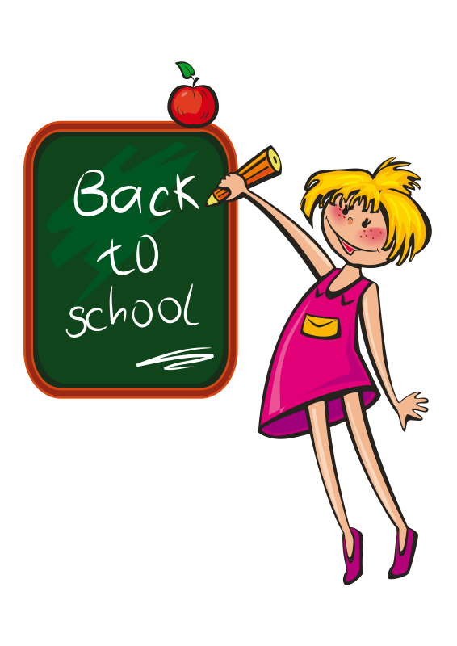

**\***

**1- Box 1 Gallon Ziploc Bags**

**1- Boxes Sandwich size Ziploc Bags**

**4- Boxes of Kleenex**

**2- Pkgs. Kleenex (Pocket Size)**

**1- Antibacterial Wipes**

**2- Hand Sanitizer**

**1- Book bag (no wheels)**

**Please put your child’s name on ALL supplies.**

**\*All Teachers will have supply baskets for students.**

**\*REPLACEMENT of supplies during the year is the**

**\*Please put your child’s name on ALL supplies.**

**\*All Teachers will have supply baskets for**

**students.**

**\*REPLACEMENT of supplies during the year**

**is the student’s responsibility**